Two Red Dot Design Awards for Stiebel Eltron

Award for new product design of small water heater and electric heater
Two new products from the Stiebel Eltron portfolio have been awarded one of the most coveted quality seals for good design worldwide, the "Red Dot Award: Product Design 2023": the SNU Plus small water heater and the CNS Plus LCD electric heater. With the product design of both appliances, the German heating and heating technology specialist Stiebel Eltron is breaking new ground - the design was only recently presented at the ISH 2023 trade fair.

"We are thrilled about the awards," says product manager Barbara Brunn. "The two appliances were realised in the new family design - the awards are therefore also a confirmation that we are on an excellent path here." The new design of the SNU Plus small water heater and the CNS electric heater from Stiebel Eltron underlines the features of the products - appearance and function go hand in hand here. The SNU Plus water heater efficiently supplies the sink with hot water to the exact degree and to the point. The desired hot water temperature can be adjusted smoothly between 35 and 85 degrees Celsius using the high-quality rotary selector with tactile detent. The wall-mounted convector CNS Plus is the ideal way to bring heat into the room comfortably, quickly and efficiently, just as required. The LC display for operation has been discreetly integrated into the top of the particularly slim unit.

The design washbasin for public areas
In combination with the Ultronic hand dryer, the two award-winning products become a perfect trio for public washrooms - as these have to meet very different requirements than private bathrooms. Hygiene must be satisfied just as much as efficiency. With the three Stiebel Eltron products for hot water preparation, hand drying and cosy warmth in the room, all these demands are met.

Red Dot Award: Product Design 2023
The Red Dot Design Award is one of the leading design competitions worldwide. The best products of each year are honoured in the Red Dot Award: Product Design. In 2023, the submitted products were evaluated in 51 competition categories. 43 jurors came together for this. They decided which submitted product designs fulfilled the criteria for a Red Dot award according to the four qualities of good design as well as against the background of their socio-cultural character, their technical focus and their design expertise.
About STIEBEL ELTRON
STIEBEL ELTRON is an internationally operating Group and is among the global market and technology leaders in the fields of building services and renewable energies. Since 1924, technical performance, quality, innovation, reliability and customer-oriented service have been defining factors in our success. With four national and five international production facilities, 26 sales organisations around the world, plus partners and agencies in 120 countries, STIEBEL ELTRON has a global presence. The annual turnover amounts to more than one billion Euros. More than 50 per cent of the turnover is generated abroad.
In 1924 in Berlin the company founder Dr Theodor Stiebel started realising his vision of developing and manufacturing products with low energy consumption, greater safety and more comfort. This objective still applies to the company today.

Picture 1
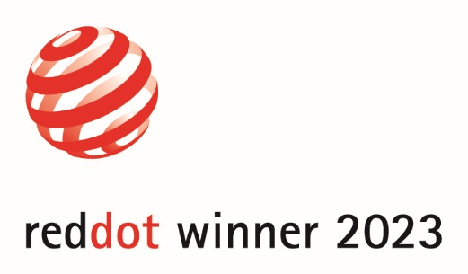 |  | Two Stiebel Eltron products have been awarded the "Red Dot Award: Product Design 2023": the SNU Plus water heater and the CNS Plus LCD electric heater.

Picture 2
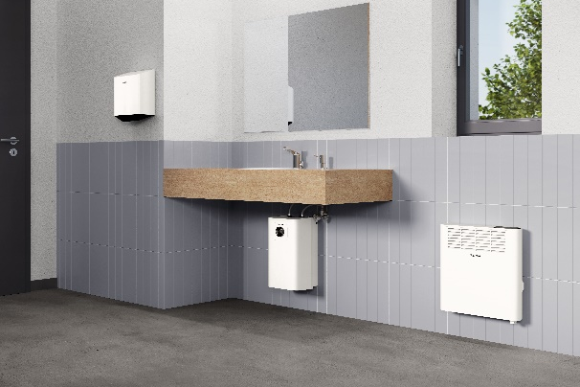 |  | Ideal equipment for public washing areas: Ultronic hand dryer, SNU Plus water storage unit and CNS Plus LCD wall-mounted convector.

Picture 3
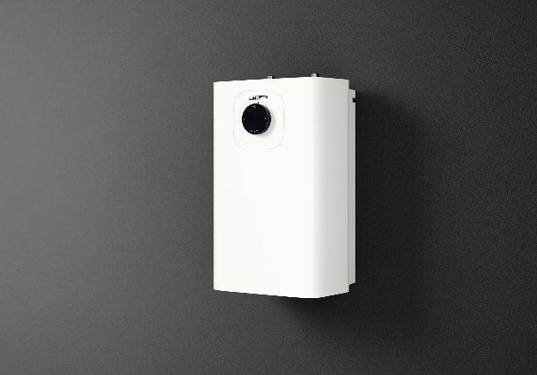 |  | The SNU Plus water heater from Stiebel Eltron receives this year's "Red Dot Award: Product Design".

Picture 4
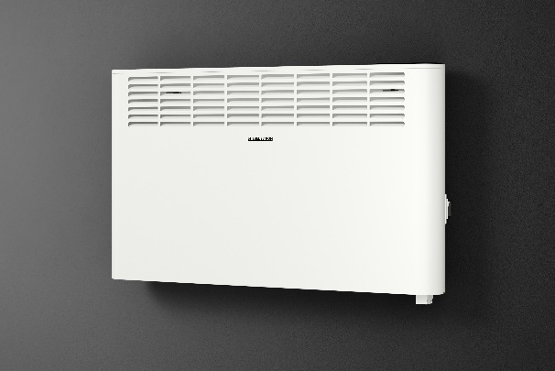 |  | Product design that impresses: The Stiebel Eltron CNS Plus LCD room heater is awarded the "Red Dot Award: Product Design 2023".
If required, please contact the following person:
STIEBEL ELTRON:
Henning Schulz
Leiter Unternehmenskommunikation
Tel.: +49 (0) 55 31 / 70 29 56 85
henning.schulz@stiebel-eltron.de

